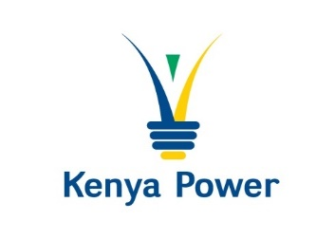

**INTENTION TO PROCURE THROUGH LIMITED TENDER**

The Kenya Power & Lighting Company PLC

intends to procure the following through Restricted Tender: -

**PROCURE SPARE PARTS FOR GARAGE EQUIPMENT AT TRANSPORT CENTRAL WORKSHOP, RUARAKA TENDER NO. KP1/9A.4/RT/TPT/19/24-25**

The tender document shall be published on **20.05.2025** to a limited number of bidders.

Those interested and may want to participant can obtain further details from [NObare@kplc.co.ke](mailto:NObare@kplc.co.ke); and [EOngalo@](mailto:EOngalo@)kplc.co.ke or 0722342894 /0703228506 before then.

This notice is issued in compliance to section 102 (1) (c) and (d) of the Public Procurement and Asset Disposal Act, 2015 and Regulation 89(8) of the Public Procurement and Asset Disposal Regulations 2020.

**GENERAL MANAGER, SUPPLY CHAIN AND LOGISTICS**

**FOR: MANAGING DIRECTOR & CEO**