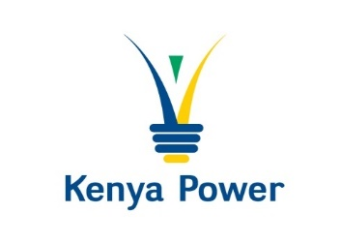

**INTENTION TO PROCURE THROUGH**

**LIMITED TENDER**

The Kenya Power & Lighting Company PLC

intends to procure the following through Restricted Tender: -

**PROCUREMENT OF AUTOMOTIVE PAINTS AND RELATED CONSUMABLES ON AN ‘AS-AND-WHEN REQUIRED’ BASIS**

**TENDER NO. KP1/9A.4/RT/TPT/21/24-25**

The tender document shall be published on **27.05.2025** to a limited number of bidders.

Those interested and may want to participant can obtain further details from [MWMacharia@kplc.co.ke](mailto:MWMacharia@kplc.co.ke); and [Eongalo@](mailto:Eongalo@)kplc.co.ke or 0719079004 before then.

This notice is issued in compliance to section 102 (1) (c) and (d) of the Public Procurement and Asset Disposal Act, 2015 and Regulation 89(8) of the Public Procurement and Asset Disposal Regulations 2020.

**GENERAL MANAGER, SUPPLY CHAIN AND LOGISTICS**

**FOR: MANAGING DIRECTOR & CEO**